EXPERIMENT:4 Create a simple cloud software application for Library book reservation system for SIMATS library using any Cloud Service Provider to demonstrate SaaS include the necessary fields such as Title of the book, author, publications, Year, edition, no of copies, Rack no, status (taken/returned) etc.

STEP:1 CREATE A APPLICATION FORM FOR LIBRARY STUDENT DETAILS.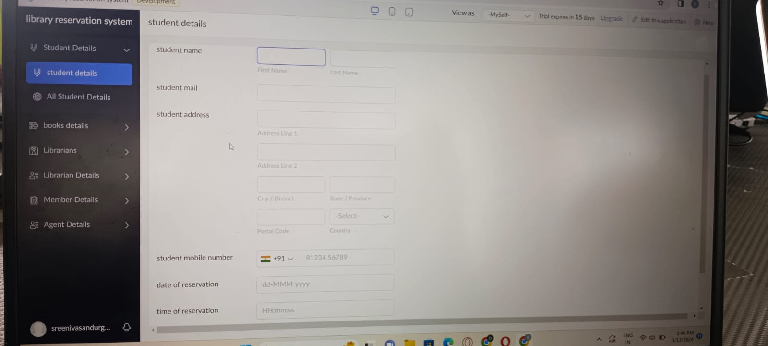

STEP:2 CRAETE A APPLICATION FORM FOR LIBRARY BOOK DETAILS:

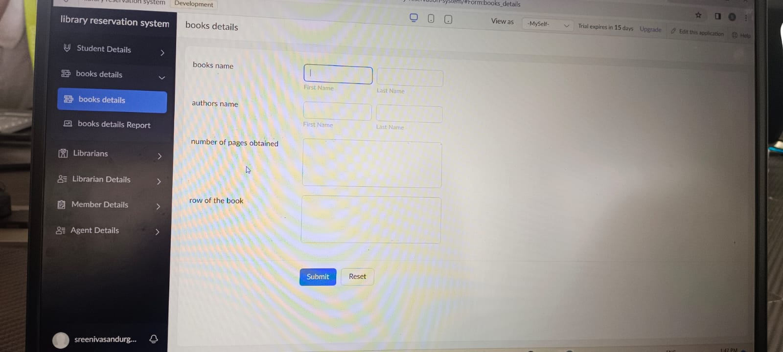

STEP:3 CREATE A APPLICATION FORM FOR LIBRARIAN DETAILS.

Create a simple cloud software application for Library book reservation system for SIMATS library using any Cloud Service Provider to demonstrate SaaS include the necessary fields such as Title of the book, author, publications, Year, edition, no of copies, Rack no, status (taken/returned) etc. 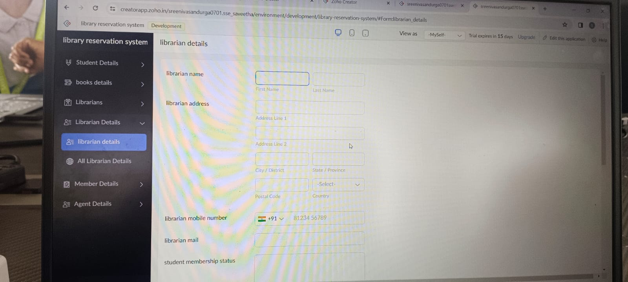

STEP:4 CREATE A APPLICATION FORM FOR MEMBER DETAILS:

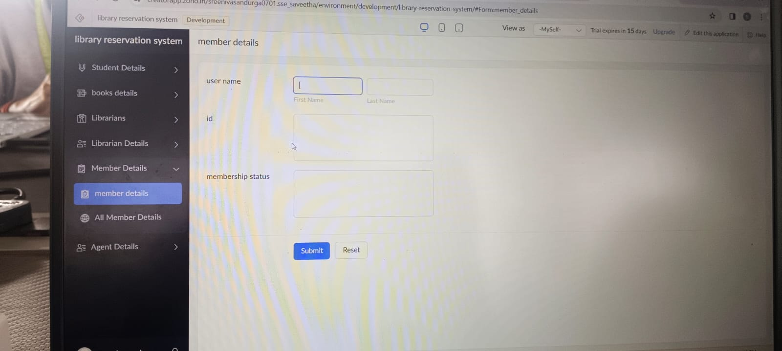  
STEP:5: CREATE A APPLICATION FORM FOR STUDENT DETAILS RESULT: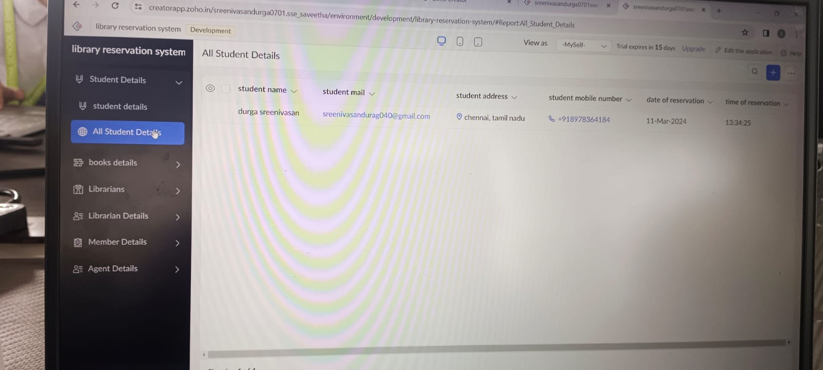

RESULT: THUS,THE PROGRAM FOR LIBRARY MANAGEMENT SYSTEMS HAS BEEN EXCEUTED SUCCESSFULLY.